
Architecture Roadmap
Project XXXX
Client YYYY
<<Note: This document provides a generic template. It may require tailoring to suit a specific client and project situation.>>
Table of Contents
1 Purpose of this Document 3
2 Project List 4
3 Time-Oriented Migration Plan 5
4 Implementation Recommendations 7

Document Information
Project Name: | Project XXX
Prepared By: |  | Document Version No: | 0.1
Title: | Architecture Roadmap | Document Version Date:
Reviewed By: |  | Review Date:
Distribution List
From | Date | Phone/Fax/Email

To | Action* | Due Date | Phone/Fax/Email
* Action Types: Approve, Review, Inform, File, Action Required, Attend Meeting, Other (please specify)
Document Version History
Version  Number | Version  Date | Revised By | Description | Filename

Purpose of this Document
<<The Architecture Roadmap lists individual increments of change and lays them out on a timeline to show progression from the Baseline Architecture to the Target Architecture. The Architecture Roadmap forms a key component of Transition Architectures and is incrementally developed throughout Phases B, C, D, E, and F within the ADM.
The purpose of this document is to define one or more architecture roadmaps for the relevant domain/sub-domain.
Note: The roadmap may also need to be synchronized with wider program/project plans or more strategic roadmaps.
Note 2: The role of the current planning functions will determine the level of detail and breadth of information on the architecture roadmaps.
Note 3: Care should be taken to minimize the duplication of effort and content in order to produce plans/roadmaps.
The purpose of this section is to describe the context around this Architecture Roadmap document. It needs to give an indication of whether this document is the sole architecture roadmap document for a domain, or one of a set, and if so, how it fits into the overall set of documents.
Mandatory/optional: This section is mandatory.
In terms of quality criteria, this section should make clear:
- Domain/sub-domain for which this Architecture Roadmap document has been produced
- Previous events and the rationale/background/context for this document
- Purpose of the Architecture Roadmap and thus this document – it should answer questions such as its usage, actions that it is going to drive, and dependencies
- Scope of this document which clearly outlines the aspects of the Architecture Roadmap that are both in and out of scope
- Stakeholders for the Architecture Roadmap and this document
- If relevant, an outline of the Architecture Roadmap documentation set>>

Project List
<<The purpose of this section is to list and briefly describe the projects that will deliver the target architecture for the domain; i.e., projects that have a significant architectural outcome and thus are illustrated on the roadmap view in the preceding section.
Mandatory/optional: This section is mandatory.
In terms of quality criteria, this section should make clear:
- All the projects that result in significant architecture change
- Unique name for these projects
- Dependencies between these projects
- Benefits of implementing these projects (including mapping to business requirements)
- Estimation of the costs for the projects>>

Projects
Project Name | Description | Dependencies between these Projects | Estimation of the Costs for the Projects

Projects Objectives

Benefits

Prioritized List of Impacted Projects
<<Prioritized list of impacted projects to implement the proposed architecture.>>

Time-Oriented Migration Plan
<<The purpose of this section is to provide a plan view (diagram) illustrating the projects that need to be completed in order to realize the target architecture. This section only needs to list projects that have a significant architectural outcome.
Mandatory/optional: This section is mandatory.
In terms of quality criteria, this section should make clear:
- View(s) of the roadmap providing an indication of:
  - Project timescales as to when they will be delivered
  - High-level categories or groups by which the projects are characterised>>
Note: XXXX have mentioned Invest, Sustain, and Sunset as categories via which they wish to view their initiatives/projects.
<<Architecture Roadmap View Example: This section needs to provide one or more views for the Architecture Roadmap. The diagrams below provide (example) views of Architecture Roadmaps. In the diagrams, projects are categorized on the roadmap by their characteristics such as their primary business objective, technology type, IT ownership, or business outcome. Project plans (Gantt charts) or textual plans can also be considered as valid views. Text describing the key concepts and notation used within the diagram will also need to be included so that users can easily read and understand the view.>>

Migration Plan
<Architecture Roadmap View Example: This section needs to provide one or more views for the Architecture Roadmap. The diagrams below provide (example) views of Architecture Roadmaps. In the diagrams, projects are categorized on the roadmap by their characteristics such as their primary business objective, technology type, IT ownership, or business outcome. Project plans (Gantt charts) or textual plans can also be considered as valid views. Text describing the key concepts and notation used within the diagram will also need to be included so that users can easily read and understand the view.>>

Migration Options
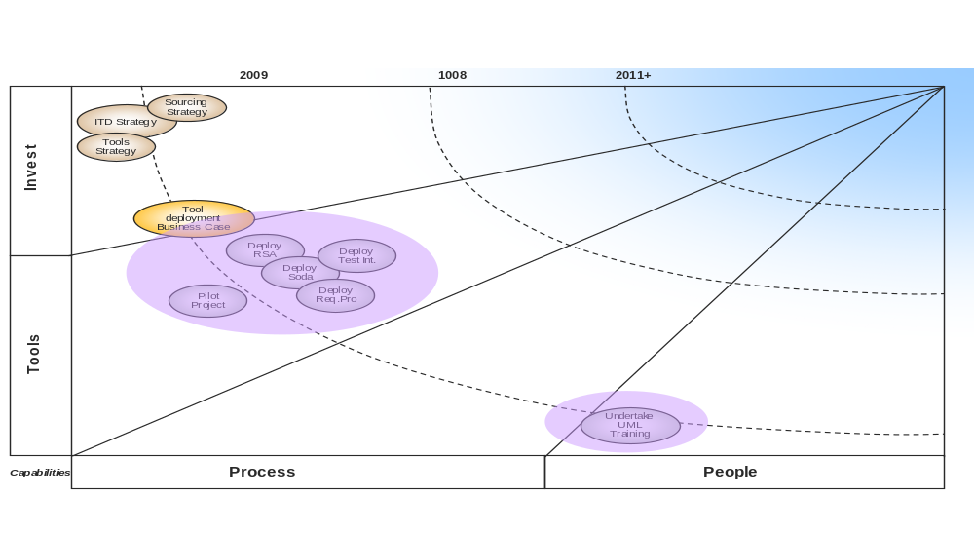

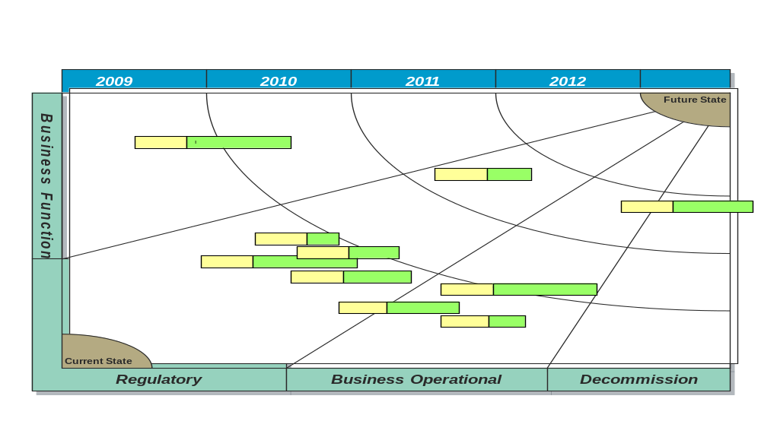

Benefits of Migration
<<Determined (including mapping to business requirements).>>

Estimated Costs of Migration Options

Implementation Recommendations
<<The purpose of this section is to determine the critical measures, issues, and known risks for each of these projects.
Mandatory/optional: This section is mandatory.
In terms of quality criteria, this section should make clear:
- Critical measures that need to be captured for the projects
- Issues that may impact the quality or delivery of these projects
- Known risks that impact the quality or delivery of these projects
- Solution building blocks that will be made available from each of these projects>>

Criteria Measures of Effectiveness of Projects
<<The purpose of this section is to determine the critical measures for each of these projects.
Mandatory/optional: This section is mandatory.
In terms of quality criteria, this section should make clear:
- Critical measures that need to be captured for the projects>>
<<This section defines the measures that need to be monitored and evaluated during the course (and at the end) of an architectural initiative to ensure that the objectives, budget, and time constraints are on track.>>

Risks and Issues
<<The purpose of this section is to determine the issues and known risks for each of these projects.
Mandatory/optional: This section is mandatory.
In terms of quality criteria, this section should make clear:
- Issues that may impact the quality or delivery of these projects
- Known risks that impact the quality or delivery of these projects>>

Solution Building Blocks (SBBs)
(Description and model.)
<<The purpose of this section is to determine the solution building blocks that will be made available from each of these projects.
Mandatory/optional: This section is mandatory.
In terms of quality criteria, this section should make clear:
- Solution building blocks that will be made available from each of these projects>>

